9 facts that explain DACA, the immigration program Trump is threatening to end

How DACA works, who it protects, and what could happen to immigrants if Trump shuts it down.
Updated by Dara Linddara@vox.com Aug 31, 2017, 11:20am EDT

The most consequential decision President Donald Trump is going to make on immigration in his first year in office isn’t about the wall, or who’s going to pay for it, or anything else he talked about incessantly on the campaign trail.
It’s about the fate of a program he didn’t mention outright, that many people didn’t know about and even fewer understood: the Deferred Action for Childhood Arrivals program, or DACA, which has protected nearly 800,000 young adult unauthorized immigrants from deportation and allowed them to work legally since 2012.
The immigrants protected through DACA grew up in the US; people might not assume they are unauthorized immigrants, and they might not have even known it themselves until they were teenagers. The program was supposed to give them a chance to build a life here.
Now, DACA could be on the chopping block. Trump is under pressure to make a decision about its future before September 5, the day a group of Republican state officials are set to sue over its constitutionality.
The prospect of DACA’s demise is throwing the program into sharp relief: calling attention to the “DREAMers” who’ve been able to benefit from it, and the ways in which their lives have been changed over the past five years.
Here’s a guide to the program, the people it protects, and what could happen in the near future.

1) DACA is a program to protect DREAMers — unauthorized immigrants brought to the US as children
In the 1990s to mid-2000s, the US started building up enforcement on the US/Mexico border, with a huge unintended consequence: Many unauthorized immigrants avoided repeated risky border crossings by settling in the US with their families. (Previously, unauthorized immigrants had mostly been working-age men who crossed back and forth to the US for work while their families stayed in their home countries.)

Around the same time, changes to US law made it nearly impossible for an immigrant to get legal status if they’d lived in the country illegally. So the children who crossed illegally into the US with their parents were growing up in a country where they could never become legal residents or citizens.
These children became known as DREAMers, after the DREAM Act, a piece of legislation meant to give them a path to citizenship first introduced in 2001. But with that legislation stalled in Congress, President Barack Obama in 2012 created the Deferred Action for Childhood Arrivals program, or DACA. While it didn’t give them a path to citizenship, DACA offered DREAMers a temporary grant of protection from deportation and a permit to work legally in the US. The protections last two years, after which immigrants can apply to renew for them.
Not all DREAMers, though, became DACA recipients. To apply for DACA, immigrants have to have come to the US before 2007, and have been 15 or younger when they arrived and younger than 31 when DACA was created in June 2012. They had to have a nearly spotless criminal record and be enrolled in high school or have a high school diploma or equivalent.
Perhaps most importantly, they have to apply. It’s estimated that about 1.3 million people would be eligible for DACA, but right now, about 800,000 people actually have it.

2) DACA recipients are part of a generation of immigrants raised alongside US citizens
Not all DREAMers are from Mexico or Central America, and plenty of them came in other ways: their parents had legal work visas but the children did not, or their legal visas expired, or they tried to seek asylum and failed.
What unites DREAMers, more than how they came to the US, is the experience they’ve had here.
Technically, immigrants are eligible for DACA if they came to the US under the age of 16. But in practice, the majority were much younger when they immigrated. In the most recent survey of 3,063 DACA recipients, conducted in August 2017 by Tom Wong of UC San Diego (for the liberal think tank the Center for American Progress and other immigrant advocacy groups), the average age that respondents said they’d arrived in the US was 6-and-a-half years old.
When defenders of DACA say that the immigrants who benefit from it are “American in all but paperwork,” or that the US is “the only country they remember,” this is what they’re talking about. Demographers call them the “1.5 generation”: unauthorized immigrants who arrived as children are technically first-generation residents of the US, because they were born in another country. But their life experiences have more in common with the US-born children of immigrants (known as the second generation).
Many DREAMers say they didn’t even know they were unauthorized immigrants until they were teenagers — often when they discovered they couldn’t join their peers in getting a driver’s license or filling out financial aid forms for college, because they didn’t have Social Security numbers.
That’s given rise to the talking point, often used by politicians, that DREAMers “were brought to the United States through no fault of their own,” or that they “are being punished for the sins of their parents.” Those talking points seek to draw a line: Adults who deliberately chose to come to (or stay in) the US without legal status should take responsibility for their actions, but children shouldn’t be blamed for being brought along.
But from the perspective of DREAMers themselves, their parents came to the US to give their children a better life, just as any other immigrant parent does — and they resist efforts to make themselves look better by making their parents look like the real villains.

3) Politicians have been talking about what to do with the DREAMers for more than 15 years
The political debate over what to do about young unauthorized immigrants is, at this point, old enough that it could apply for DACA itself. The first proposal to allow people who’d come to the US as children to apply for legal immigrant status and eventually become citizens, was introduced in 2001 by Sen. Orrin Hatch (R-UT) and Sen. Maria Cantwell (D-WA). It was called the DREAM Act — Development, Relief and Education for Alien Minors— a name that versions of the bill have kept ever since.
For a while, the DREAM Act was seen as a moderate alternative to legalizing all 11 million unauthorized immigrants in the US. But with both Democrats and Republicans divided on immigration during the George W. Bush era — and with Republicans moving to the right on immigration under Barack Obama — it was never quite popular enough to get the 60 votes needed to break a filibuster in the Senate. In the most recent attempt, in December 2010, the bill passed the House and got a majority of votes in the Senate, but failed to clear 60.
By that time, the risk that a DREAMer would get deported was much higher than it was in 2001, as the federal government had ramped up deportations to 400,000 a year. Because DREAMers were politically sympathetic — majorities of Americans wanted them to stay in the US — and well-integrated into their communities, they were sometimes able to raise public alarm when they were slotted for deportation — sometimes getting the federal government to back down.
But sticking around and hoping not to get deported wasn’t a real solution.
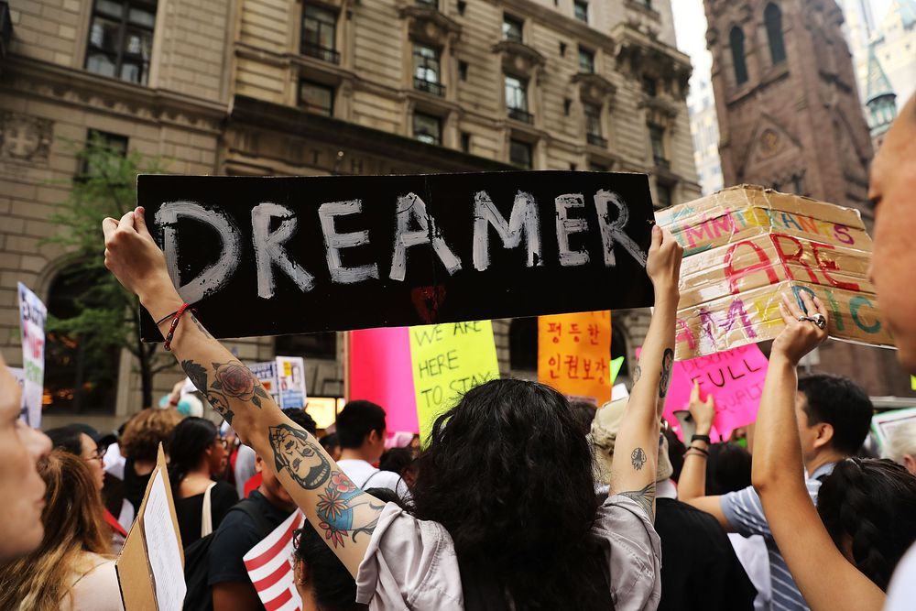Photo by Spencer Platt/Getty Images

4) DREAMers aren’t all valedictorians — but they are integrated into the US
One of the reasons that legalizing or protecting DREAMers has been politically popular — even when legalizing other unauthorized immigrants, including their parents, has not — is the stereotype of DREAMers as high school valedictorians and high-achieving college students. This stereotype has been pushed by politicians on both sides of the aisle since the early days of the DREAM Act, and it’s the angle that much of the media coverage took in calling attention to the problem throughout the 2000s.
There certainly are high-achieving DREAMers. But as a whole, they’re more diverse and less exceptional than the stereotype suggests — and the cliché of the DREAMer valedictorian can obscure just how much harder it is to succeed without legal status in the US.
According to 2014 estimates from the Migration Policy Institute, nearly 400,000 young immigrants who would otherwise qualify for DACA don’t meet the educational requirements for it: They dropped out of high school and don’t have a GED. Even immigrants who are DACA-eligible often don’t go beyond high school; only 57,000 of them, or about 5 percent, have bachelor’s degrees, with another 20 percent currently enrolled in college.
Given that unauthorized immigrants are likely to grow up in lower-income households and can’t get federal financial aid, including federal student loans, this isn’t necessarily surprising. But it’s also true that some immigrants have been dissuaded from pursuing their educational and career goals by their unauthorized status.
Sociologist Roberto Gonzales of Harvard calls this the “transition to illegality”: Once teenagers find out the truth about being unauthorized, they have to adjust their expectations of what they can achieve in life to match their new reality. Many respond by losing motivation to succeed in school or pursue high-status careers, because they can’t imagine how it would be possible for an “illegal immigrant” to succeed.
The “transition to illegality” usually doesn’t lead to people trying to leave the US — it just leads to them seeing their own lives as more like their parents’. They’re fluent in English, and are often close to American citizens: According to Wong’s survey, 25 percent of DACA recipients have at least one US-born child; 73 percent have at least one US citizen as a member of their immediate family (child, spouse or sibling). They’re still integrated into America. They just haven’t seen themselves as Americans.

5) President Obama gave DREAMers a way to protect themselves, temporarily, from deportation
After the 2010 failure of the DREAM Act, President Obama claimed that the immigrants who would be eligible for legalization under it weren’t being deported anyway, since his administration was targeting “high-priority” immigrants (like those with criminal records) rather than “low-priority” immigrants who’d lived quietly in the US for years. But federal immigration agents were still deporting “low-priority” immigrants, including DREAMers.
So in summer 2012, rather than relying on Immigration and Customs Enforcement agents to protect immigrants by declining to deport them, the administration decided to allow DREAMers to apply for protection from deportation themselves.
In June 2012, President Obama announced the Deferred Action for Childhood Arrivals program. It allows young unauthorized immigrants who meet certain criteria to apply for a commitment from the federal government for "deferred action" — that is, a commitment not to initiate deportation proceedings — for two years. Successful applicants also receive a work permit.
DACA wasn’t a legalization program — technically speaking, immigrants who are “DACAmented” are lawfully present in the US, but don’t have legal status.
It’s an important policy distinction. Having DACA doesn’t give immigrants any path to becoming legal permanent residents or citizens. Still, being lawfully present means that they’re able to get driver’s licenses even in states that don’t usually allow unauthorized immigrants to drive legally.

But it’s also a reflection of the line between the powers the executive branch has on immigration and the powers reserved for Congress. The executive branch can’t legalize anybody. But it’s fairly common for presidents to allow certain groups of immigrants to apply for temporary relief and grant those requests on a case-by-case basis. (In 2005, for example, the George W. Bush administration allowed foreign students affected by Hurricane Katrina to apply for deferred action; in 2009, the Obama administration granted deferred action to widows and widowers of US citizens and their children.)
When DACA was created, Democrats still hoped that Congress would pass a broad immigration reform bill in the near future. And in 2013, the Senate passed just such a bill. But the House never acted, and in the years since then, the common ground between Democrats and Republicans has gotten ever smaller. So DACA has gone from a short-term placeholder until a more permanent agreement can be made to the only hope, for now, for the nearly 800,000 people who have it.

6) DACA has improved upward mobility for the people who have it, but its benefits can’t really be quantified
All available research suggests that immigrants who’ve received DACA protections have been able to go further, educationally and economically, than other unauthorized immigrants — or than they would have without DACA.
Wong’s August 2017 survey found that annual earnings had increased 80 percent under DACA — from an average of $20,000 to an average of $36,000. (This includes immigrants who are working part time, or who are working while enrolled in school, as well as those with full-time jobs.) Sixty-five percent had bought their first car; 16 percent had become homeowners.
Five percent of DACA recipients had started their own businesses. Sixty percent of DACA recipients above the age of 25 — in other words, those most likely to have been in the workforce before DACA was rolled out in 2012 — said that with DACA they’d been able to find jobs that better suited the education and training they already had; 61 percent said they’d been able to find jobs that suited the careers they wanted to have.
Cyrus McCrimmon/The Denver Post via Getty
DACA recipients were already primed to do better than many unauthorized immigrants because of their fluency in English and education in the US: in 2014, a Migration Policy Institute analysis found that the population eligible for DACA (including both those who had applied and those who hadn’t) was less likely to be in professional or managerial jobs than US citizens, but much more likely to be working white-collar jobs than other unauthorized immigrants.
But having DACA allowed immigrants to capitalize on those gains in an important way. A 2014 study conducted by the Institute for Research on Labor and Employment at UCLA found that 84 percent of immigrants with DACA were employed compared to 68 percent of their unauthorized peers, and that DACA recipients earned 20 percent more than similar immigrants without DACA.
There might be more to the benefits of DACA than simply the fact that recipients can work legally. If the “transition to illegality” forced many immigrants to narrow their ambitions, there’s evidence DACA has opened them back up. Its respondents aren’t just finding jobs, but careers: in a 2015 survey, 80 percent of respondents agreed that they feel more likely to achieve their career goals now that they have DACA. They’re buying homes in the US with the intent to stay.
RELATED

3 years later, the immigrants Obama protected are feeling less afraid — and more American
In a survey conducted a year after DACA, in 2013, most DACA recipients felt safer after getting protected from deportation: 66 percent said they were no longer afraid, and 64 percent said they felt more like they belonged in the US. As the program continued, those feelings only grew. In 2015, 78 percent of DACA recipients said they were no longer afraid. And 72 percent said they felt like they belonged in America.
That feeling of security allowed them to plan their futures. It freed them from some of the mental health damage that constant deportation stress can cause. And it allowed them to go from being unable to imagine themselves anywhere but America to seeing themselves as Americans.

7) Trump, or the courts, might put DACA to an end — but the details are still unclear
If Trump doesn’t act to end DACA before September 5, a group of state attorneys general, led by Texas, are threatening to sue to do it for him. They want to ask a federal judge who already ruled one Obama-era deferred action program unconstitutional (the Deferred Action for Parents of Americans program, or DAPA, which was stopped before going into effect in 2015) to do the same for DACA.
The lawsuit would probably result in DACA getting put on hold at some point — though it wouldn’t be at all clear when, or how.
The Trump administration is reportedly trying to delay the potential lawsuit, to give the president more time to decide what to do with DACA. Because in addition to the question of whether or not to fight the states in court to protect DACA, there’s the question of how Trump would end the program.
And to DREAMers, the details matter a ton.
It’s theoretically possible that Trump could not just tell the federal government not to approve any new applications for DACA protection, but could revoke the protections and work permits for the 800,000 people who already have them — effective immediately. This would cause utter chaos. Luckily, it seems unlikely.
It appears more plausible that President Trump will declare that people can keep their current work permits, but no new DACA applications will be approved — shutting out people who are currently 15 or younger from protections, as well as the hundreds of thousands of immigrants who theoretically qualify but never applied. (Immigrants from Asian countries, for example, were relatively less likely to apply for DACA, either because they were worried about the government getting their information or because they simply didn’t know what the program was.)
That leaves the question of what happens when DACA recipients’ current two-year work permits expire — as they will, if unable to renew DACA, in the coming weeks and months.
Trump could allow DACA recipients to renew one more time — giving Congress a couple of years to come up with a more permanent solution, or simply kicking the can down the road. He could set a deadline after which no new DACA renewals will be granted, meaning that anyone whose permit expires after that date will simply become unauthorized again.
In order to satisfy the demands of the Republican state officials threatening to sue, though, Trump would have to declare that the government will stop renewing DACA applications, period. That would have the effect of ending the program over the next two years — with tens of thousands of people losing their DACA protections every month.

8) Losing DACA wouldn’t automatically mean deportation. But it could be worse than not having it at all.
What losing DACA would mean varies from immigrant to immigrant. Immigrants working full-time jobs would have to leave them to comply with the law, or continue working at legal risk to themselves and their employers. Immigrants in school would be able to remain enrolled, in nearly all cases, but some might have trouble retaining their financial aid for the rest of their educations (in addition to not knowing what jobs they could get in the US with the degrees they’re working to obtain).
And then there’s the threat of deportation.
Because DACA recipients gave extensive personal information to the government when they applied, many of them could easily be tracked down, arrested, and placed in deportation proceedings once their DACA expired — if the Trump administration chose to do so. Under Obama, DACA information was protected from ICE agents by privacy regulations, but an executive order signed by President Trump in January relaxed those restrictions.
In theory, Trump administration officials claim they’re targeting immigrants with criminal records for deportation. In practice, it appears deportation efforts are going after the lowest-hanging fruit — the immigrants they can most easily track down and pick up. If that’s true, it could put DACA recipients at substantial risk.
Aric Crabb/Bay Area News Group via Getty
There are too many DACA recipients for the administration to arrest all of them, much less deport them — and because DACA recipients haven’t been previously deported or ordered deported, it wouldn’t be possible to without putting them through a yearslong immigration court process. But the risk of deportation could be, if anything, higher after DACA than it was beforehand.
In the meantime, immigrants stripped of DACA protections could attempt to continue to live the lives they’d been living with DACA: working, driving around, being “undocumented and unafraid.” If they did that, they’d put themselves in legal jeopardy multiple times a day, and increase the risk of their deportation.
They could try to prepare to leave the country: selling the car or house they purchased while protected by DACA, trying to find a country that would welcome the skills they’d no longer have the opportunity to use in the US. But for a cohort of people who grew up in the US, and who have spent the last half-decade living here with some legitimacy, that wouldn’t be an easy step to take — if it were, more of them would have taken it rather than live under the uncertainty of DACA to begin with.
Or they could try to return to the shadows — taking the sort of jobs they had before DACA. They could try to transition back to illegality.

9) The threat of losing DACA creates its own kind of uncertainty
For the moment, the decision of “what to do if DACA ends” is still hypothetical. It’s possible that the Trump administration won’t make a decision before September 5 — or even that it will be able to persuade the states to extend their deadline for a lawsuit.
But that doesn’t remove the threat to DACA recipients. It just leaves them in limbo about their futures for longer.
Since Trump was elected, DACA recipients have been worried about what’s going to happen to them. Many were concerned that he was going to strip them of their protections and work permits on his first day in office. They dealt with several rounds of unfounded rumors in the early weeks of his administration that he was about to sign an executive order that would prevent them from renewing DACA.
RELATED

Donald Trump isn't president yet. But he's already making 740,000 immigrants live in fear.
In the meantime, they’ve had to make the same decisions that any other person in their late teens, 20s, or early 30s has to make from November of one year to August of another: whether to change jobs or even careers, whether they should go back to school or take a break from school to work, whether to move to a new town or stay at home to save money and help family.
They’ve done all this with the knowledge that they could be making plans for a future that could evaporate with the stroke of a pen.
Simply delaying a decision about whether to end DACA doesn’t remove that cloud from over their heads. Only the decision itself — either knowing for sure that their days with DACA are numbered, or knowing that the administration will keep the program and fight for them in court — will do that.

Was this article helpful?

