Human losses by country
Total deaths
Human losses of World War II by country
Country | Total population  1/1/1939 | Military  deaths | Civilian deaths due to  military activity and crimes against humanity | Total  deaths | Deaths as % of  1939 population
 Albania | 1,073,000 | 30,000 |  | 30,000 | 2.81
Australia | 6,998,000 | 39,800 | 700 | 40,500 | .57
Austria | 6,650,000 | Included with Germany | 120,000 | 120,000
Belgium | 8,387,000 | 12,100 | 75,900 | 88,000 | 1.05
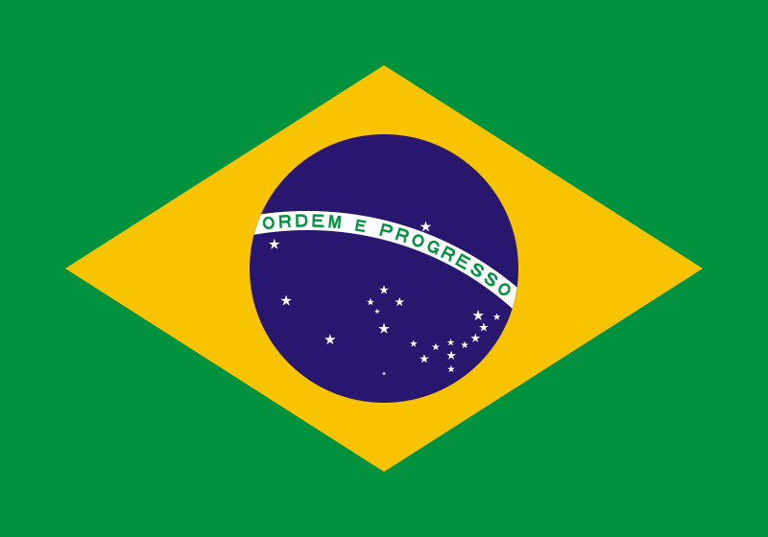 Brazil | 40,289,000 | 1,000 | 1,000 | 2,000 | .02
Bulgaria | 6,458,000 | 22,000 | 3,000 | 25,000 | .38
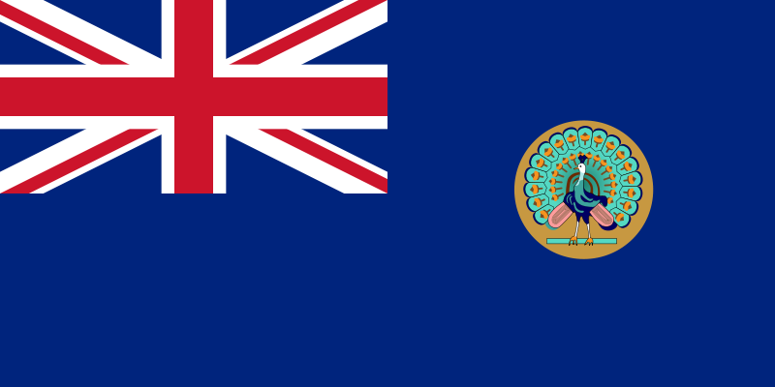 Burma | 16,119,000 | 22,000 | 250,000 | 272,000 | 1.69
Canada | 11,267,000 | 45,400 |  | 45,400 | .40
China | 517,568,000 | 3,000,000  to 4,000,000 | 7,000,000  to 16,000,000 | 10,000,000  to 20,000,000 | (1.93 to 3.86)
Cuba | 4,235,000 |  | 100 | 100
Czechoslovakia | 15,300,000 | 25,000 | 300,000 | 325,000 | 2.12
Denmark | 3,795,000 | 2,100 | 1,100 | 3,200 | .08
Dutch East Indies | 69,435,000 |  | 3,000,000  to 4,000,000 | 3,000,000  to 4,000,000 | (4.3 to 5.76)
Estonia (within 1939 borders) | 1,122,000 |  | 50,000 | 50,000 | 4.44
Ethiopia | 17,700,000 | 5,000 | 95,000 | 100,000 | .6
Finland | 3,700,000 | 95,000 | 2,000 | 97,000 | 2.62
France | 41,700,000 | 217,600 | 350,000 | 567,600 | 1.35
 French Indochina | 24,600,000 |  | 1,000,000  to 1,500,000 | 1,000,000  to 1,500,000 | (4.07 to 6.1)
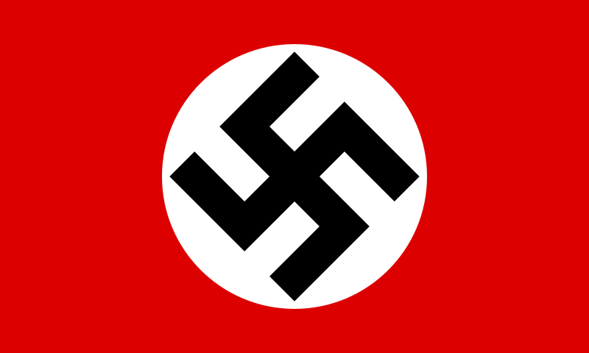 Germany | 69,850,000 | 5,530,000 | 1,100,000  to 3,150,000 | 6,630,000  to 8,680,000
Greece | 7,222,000 | 20,000  to 35,100 | 300,000  to 770,000 | 320,000  to 805,100 | (4.44 to 11.15)
Hungary | 9,129,000 | 300,000 | 280,000 | 580,000 | 6.35
Iceland | 119,000 |  | 200 | 200 | .17
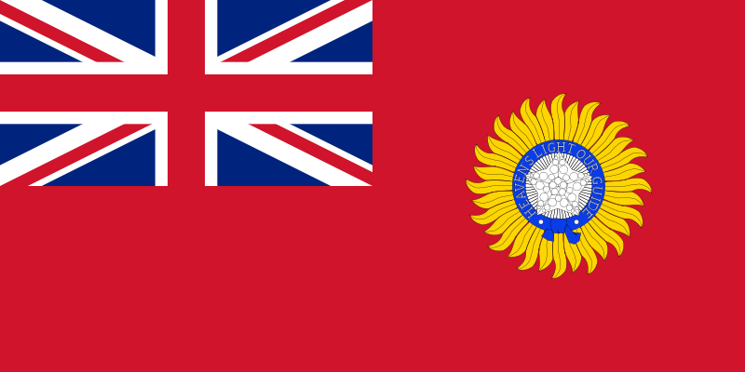 India (British) | 378,000,000 | 87,000 | 1,500,000  to 2,500,000 | 1,587,000  to 2,587,000 | (0.42 to 0.68)
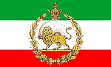Iran | 14,340,000 | 200 |  | 200 | .00
Iraq' | 3,698,000 | 500 |  | 500 | .01
Ireland | 2,960,000 |  | 200 | 200 | .00
Italy | 44,394,000 | 301,400 | 155,600 | 457,000 | 1.03
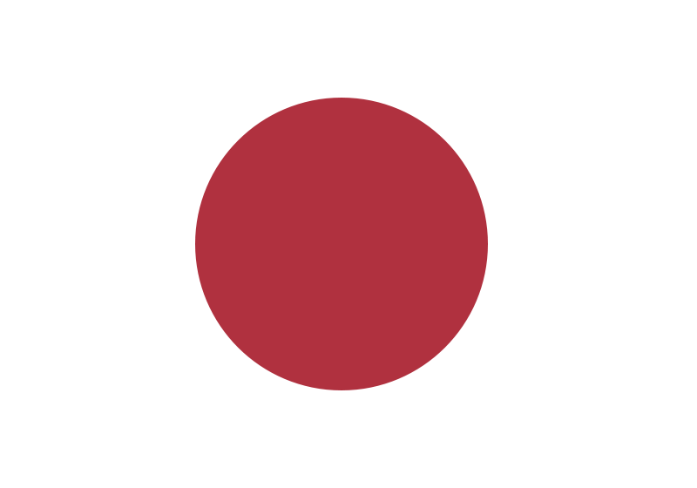 Japan | 71,380,000 | 2,120,000 | 500,000  to 1,000,000 | 2,620,000 to 3,120,000 | (3.67 to 4.37)
 Korea | 23,400,000 |  | 378,000  to 483,000 | 378,000  to 483,000 | (1.6 to 2.06)
 Latvia (within 1939 borders) | 1,951,000 |  | 230,000 | 230,000 | 11.78
 Lithuania (within 1939 borders) | 2,442,000 |  | 350,000 | 350,000 | 14.33
 Luxembourg | 295,000 |  | 2,000 | 2,000 | .68
 Malaya | 4,391,000 |  | 100,000 | 100,000 | 2.28
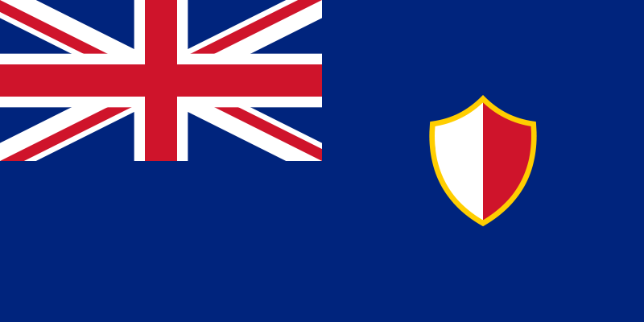 Malta | 269,000 |  | 1,500 | 1,500 | .56
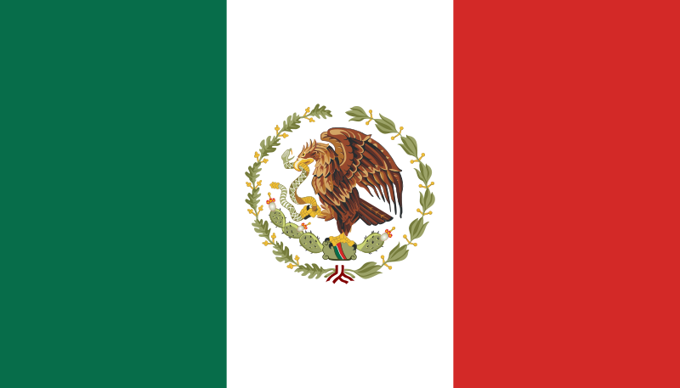 Mexico | 19,320,000 |  | 100 | 100 | .00
 Mongolia | 819,000 | 300 |  | 300 | .04
Nauru | 3,400 |  | 500 | 500 | 14.7
 Nepal | 6,000,000 | Included with British Indian Army
Netherlands | 8,729,000 | 17,000 | 284,000 | 301,000 | 3.45
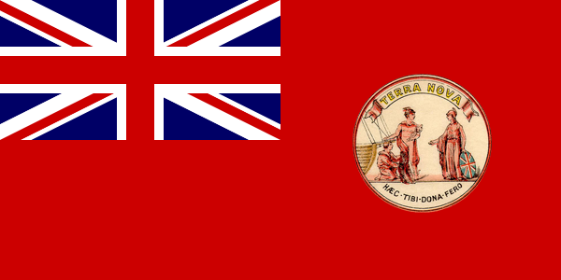 Newfoundland | 300,000 | included with the U.K. | 100 | 100 | .03
New Zealand | 1,629,000 | 11,900 |  | 11,900 | .73
Norway | 2,945,000 | 3,000 | 6,500 | 9,500 | .32
Papua and New Guinea | 1,292,000 |  | 15,000 | 15,000 | 1.17
Philippines | 16,000,000 | 57,000 | 500,000  to 1,000,000 | 557,000  to 1,057,000 | (3.48 to 6.6)
Poland (within 1939 borders) | 34,849,000 | 240,000 | 5,380,000  to 5,580,000 | 5,620,000  to 5,820,000 | (16.1 to 16.7)
Portuguese Timor | 500,000 |  | 40,000  to 70,000 | 40,000  to 70,000 | (8.00 to 14.00)
Romania (within 1939 borders) | 19,934,000 | 300,000 | 500,000 | 800,000 | 4.01
Ruanda-Urundi | 4,200,000 |  | 0 to 300,000 | 0 to 300,000 | (0.00 to 7.1)
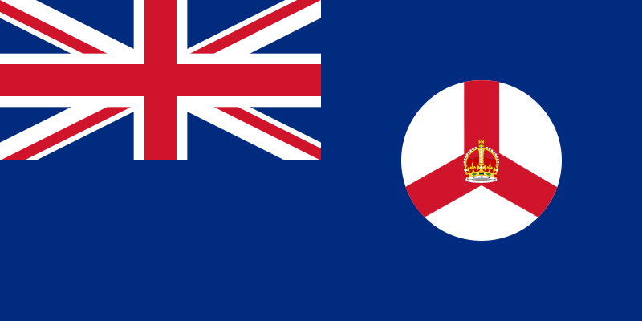 Singapore | 728,000 |  | 50,000 | 50,000 | 6.87
South Africa | 10,160,000 | 11,900 |  | 11,900 | .12
South Pacific Mandate | 1,900,000 |  | 57,000 | 57,000 | 3.00
Soviet Union | 168,524,000 | 8,800,000  to 10,700,000 | 12,700,000  to 14,600,000 | 23,400,000 | 13.88
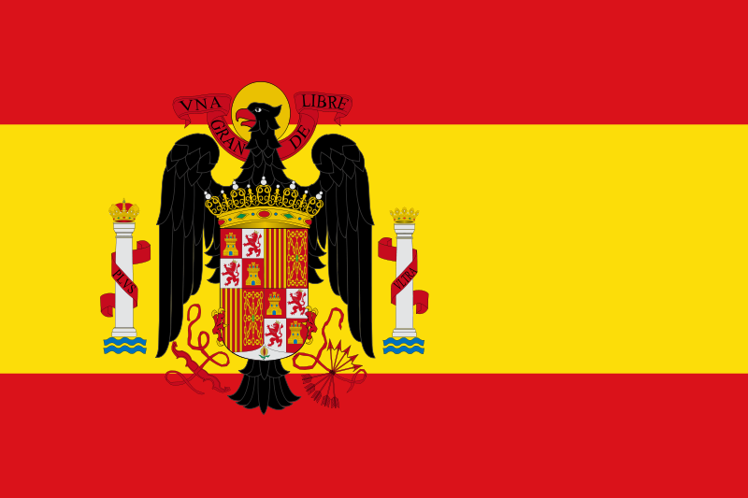Spain | 25,637,000 | Included with the German Army
Sweden | 6,341,000 |  | 600 | 600 | .01
Switzerland | 4,210,000 |  | 100 | 100 | .00
Thailand | 15,023,000 | 5,600 | 2,000 | 7,600 | .04
United Kingdom | 47,760,000 | 383,800 | 67,100 | 450,900 | .94
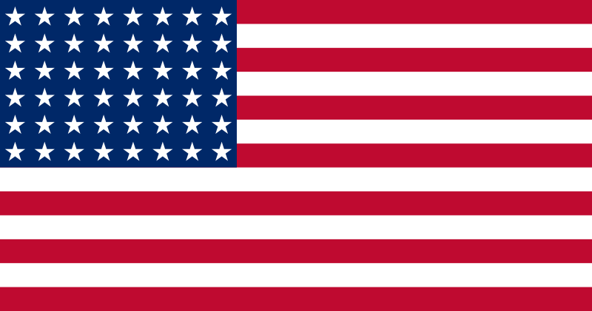 United States | 131,028,000 | 416,800 | 1,700 | 418,500 | .32
Yugoslavia | 15,400,000 | 446,000 | 581,000 | 1,027,000 | 6.67
Totals | 1,978,167,400 | 22,572,400  to 25,487,500 | 37,585,300  to 55,207,000 | 62,171,400  to 78,511,500 | (3.17 to 4.00)

Civilian casualties include deaths caused by strategic bombing, Holocaust victims, Japanese war crimes, population transfers in the Soviet Union, Allied war crimes and deaths due to war related famine and disease. The exact breakdown is not always provided in the sources cited.

Total Soviet losses in the postwar 1946–91 boundaries were 26.6 million. (13.5% of the total population of 196.7 million)

Total Polish losses in the postwar 1946 boundaries were about 3,600,000 (15.8% of the total population of 23.3 million)

Total Romanian losses in the postwar 1946 boundaries were 500,000 (2.5% of the total population of 15.9 million)

Total losses of Czechoslovakia in the post war 1946-1991 borders were 280,000 (1.9% of the total population of 14.6 million.)
Human Losses of The Third Reich in World War II (Included in above figures of total war dead)
Country | Population  1939 | Military  deaths | Civilian  deaths | Total  deaths | Deaths as  % of 1939  population
Austria | 6,650,000 | 260,000 | 120,000 | 380,000 | 5.7
Germany (within 1937 borders, Danzig & Memel Territory) | 69,850,000 | 4,450,000 | 1,050,000  to 2,450,000 | 5,500,000  to 6,900,000 | 7.9 to 10.0
Ethnic Germans and other nations | 6,700,000 | 600,000 | 50,000  to 700,000 | 650,000  to 1,300,000 | 9.7 to 19.4
Soviet citizens in the German military | 800,000 | 220,000 |  | 220,000 | 27.5
Totals | 84,000,000 | 5,530,000 | 1,220,000  to3,270,000 | 8,800,000 | (8.0  to 10.5)

USSR
Human Losses of The USSR in World War II (Included in the above figures of total war dead)
Country | Population  1939 | Military  deaths | Civilian  deaths | Total  deaths | Deaths as  % of 1939  population
Soviet Union  (within 1939 borders) | 168,524,000 | 8,800,000  to 10,700,000 | 14,600,000  to 12,700,000 | 23,400,000 | 13.9
Estonia  (within 1939 borders) | 1,122,000 |  | 50,000 | 50,000 | 4.5
Latvia  (within 1939 borders) | 1,951,000 |  | 230,000 | 230,000 | 11.6
Lithuania  (within 1939 borders) | 2,442,000 |  | 350,000 | 350,000 | 14.5
Poland  Eastern Regions-  (figures included with Poland) | 11,591,000 |  | 2,000,000 | 2,000,000 | 17.2
Romania  Bessarabia & Bukovina  (figures included with Romania) | 3,700,000 |  | 300,000 | 300,000 | 8.1
Czechoslovakia-Carpathian Ruthenia  (figures included with Czechoslovakia) | 700,000 |  | 50,000 | 50,000 | 7.1
Less: Population Transfers -Net | (1,237,000)
Growth of Population 1939–mid-1941 | 7,923,000
Soviet deaths included in the German Military |  |  | 220,000 | 220,000
Total population of USSR in June 1941, within postwar 1946-1991 borders | 196,716,000 | 8,800,000  to 10,700,000 | 17,800,000  to 15,900,000 | 26,600,000 | 13.5

Holocaust deaths
Included in the above figures of total war dead are the victims of the Holocaust
Jews: The Holocaust is the term generally used to describe the genocide of approximately six million European Jews during World War II, Martin Gilbert estimates 5.7 million (78%) of the 7.3 million Jews in German occupied Europe were Holocaust victims. Other estimates for Holocaust deaths range between 4.9 to 6.0 million Jews.
Some scholars maintain that the definition of the Holocaust should also include the other victims persecuted and killed by the Nazis. Using this definition, the total number of Holocaust victims is between 11 million and 17 million people.
Roma: Most estimates of Roma (Gypsies) victims range from 130,000 to 500,000 Ian Hancock, Director of the Program of Romani Studies and the Romani Archives and Documentation Center at the University of Texas at Austin, has argued in favour of a higher figure of between 500,000 and 1,500,000 Roma dead Hancock writes that, proportionately, the death toll equaled "and almost certainly exceed[ed], that of Jewish victims."
Handicapped persons: 150,000 to 200,000 handicapped persons were victims of Nazi euthanasia.

Prisoners of War: POW deaths in Nazi captivity totaled 3.1 Million including 2.6 to 3 million Soviet prisoners of war.
Ethnic Poles: 1.8 to 1.9 million civilians were victims (see Nazi crimes against ethnic Poles).
Russians, Ukrainians and Belarusians: Sources in the English language estimate 4.5 to 11.7 million Soviet civilians were victims of Nazi ethnic cleansing and the war; A report published by the Russian Academy of Science in 1995 put the civilian death toll due to the German occupation at 13.7 million Contemporary Russian sources use the terms "genocide" and "premeditated extermination" when referring to civilian losses in the occupied USSR. Civilians killed in reprisals during the Soviet partisan war and wartime related famine account for a major part the huge toll. Russian sources include Jewish Holocaust deaths with total civilian deaths and do not list them separately
Homosexuals: 10,000-15,000 Gay men perished in Nazi concentration camps.
Other victims of Nazi persecution: Between 1,000 to 2,000 Roman Catholic clergy about 1,000 Jehovah's Witnesses; and an unknown number of Freemasons. perished in Nazi prisons and camps. "The fate of black people from 1933 to 1945 in Nazi Germany and in German-occupied territories ranged from isolation to persecution, sterilization, medical experimentation, incarceration, brutality, and murder." During the Nazi era Communists, Socialists, Social Democrats, and trade union leaders were victims of Nazi persecution.
Serbs: The Croatian allies of Nazi Germany murdered between 320,000 and 340,000 ethnic Serb residents of Croatia and Bosnia during the war.

*Jewish Holocaust deaths
Included in the above figures of total war dead are the Jewish victims of the Holocaust.
Country | Pre War Jewish population | Low Estimate | High Estimate
Austria | 191,000 | 50,000 | 65,000
Belgium | 60,000 | 25,000 | 29,000
Czech Republic(Bohemia & Moravia) | 92,000 | 77,000 | 78,300
Denmark | 8,000 | 60 | 116
Estonia | 4,600 | 1,500 | 2,000
France | 260,000 | 75,000 | 77,000
Germany | 566,000 | 135,000 | 142,000
Greece | 73,000 | 59,000 | 67,000
Hungary(borders 1940)[53] | 725,000 | 502,000 | 569,000
Italy | 48,000 | 6,500 | 9,000
Latvia | 95,000 | 70,000 | 72,000
Lithuania | 155,000 | 130,000 | 143,000
Luxembourg | 3,500 | 1,000 | 2,000
Netherlands | 112,000 | 100,000 | 105,000
Norway | 1,700 | 800 | 800
Poland | 3,250,000 | 2,700,000 | 3,000,000
Romania(Borders 1940) | 441,000 | 121,000 | 287,000
Slovakia | 89,000 | 60,000 | 71,000
Soviet Union(Borders 1939) | 2,825,000 | 700,000 | 1,100,000
Yugoslavia | 68,000 | 56,000 | 65,000
Total | 9,067,000 | 4,869,860 | 5,894,716

Roma losses by country
Included in the figures of total war dead are the Roma victims of the Nazi persecution, some scholars include the Roma deaths with the Holocaust.
The following figures are from The Columbia Guide to the Holocaust.
Country | Pre War Roma population | Low Estimate | High Estimate
Austria | 11,200 | 6,800 | 8,250
Belgium | 600 | 350 | 500
Czech Republic(Bohemia & Moravia) | 13,000 | 5,000 | 6,500
Estonia | 1,000 | 500 | 1,000
France | 40,000 | 15,150 | 15,150
Germany | 20,000 | 15,000 | 15,000
Greece | ? | 50 | 50
Hungary | 100,000 | 1,000 | 28,000
Italy | 25,000 | 1,000 | 1,000
Latvia | 5,000 | 1,500 | 2,500
Lithuania | 1,000 | 500 | 1,000
Luxembourg | 200 | 100 | 200
Netherlands | 500 | 215 | 500
Poland | 50,000 | 8,000 | 35,000
Romania | 300,000 | 19,000 | 36,000
Slovakia | 80,000 | 400 | 10,000
Soviet Union(Borders 1939) | 200,000 | 30,000 | 35,000
Yugoslavia | 100,000 | 26,000 | 90,000
Total | 947,500 | 130,565 | 285,650

Japanese war crimes
Included with total war dead are victims of Japanese war crimes
R. J. Rummel estimates the civilian victims at 5,424,000. Detailed by country: China 3,695,000; Indochina 457,000; Korea 378,000; Indonesia 375,000; Malaya-Singapore 283,000; Philippines 119,000, Burma 60,000 and Pacific Islands 57,000. Rummel estimates POW deaths in Japanese custody at 539,000 Detailed by country: China 400,000; French Indochina 30,000; Philippines 27,300; Netherlands 25,000; France 14,000; UK 13,000; UK-Colonies 11,000; US 10,700;

Australia 8,000.
Werner Gruhl estimates the civilian victims at 20,365,000. Detailed by country: China 12,392,000; Indochina 1,500,000; Korea 500,000; Dutch East Indies 3,000,000; Malaya and Singapore 100,000; Philippines 500,000; Burma 170,000; Forced laborers in Southeast Asia 70,000, 30,000 interned non-Asian civilians; Timor 60,000; Thailand and Pacific Islands 60,000. Gruhl estimates POW deaths in Japanese captivity at 331,584. Detailed by country: China 270,000; Netherlands 8,500; U.K. 12,433; Canada 273; Philippines 20,000; Australia 7,412; New Zealand 31; and the United States 12,935
The historian Chalmers Johnson has written that “the Japanese slaughtered as many as 30 million Filipinos, Malays, Vietnamese, Cambodians, Indonesians and Burmese, at least 23 million of them ethnic Chinese
Out of “60,000" Indian Army POWs taken at the Fall of Singapore, 11,000 died in captivity
There were 14,657 deaths among the total 130,895 western civilians interned by the Japanese due to famine and disease.
Deportations in the USSR
The deaths of 400,000 civilians deported during the Soviet annexations in 1939–40 are included with World War II casualties.
Russian sources list Axis Prisoner of war deaths of 580,589 in Soviet captivity; however some western scholars estimate the total at between 1.7 and 2.3 million.
Military casualties by branch of service
Casualties of World War II by Branch of Service
Country | Branch of service | Number served | Killed/missing | Wounded | Prisoners of war Captured | Percent killed
Germany | Army | 13,600,000 | 4,202,000 |  |  | 30.9
 | Air Force(including infantry units) | 2,500,000 | 433,000 |  |  | 17.3
 | Navy | 1,200,000 | 138,000 |  |  | 11.5
 | Waffen SS | 900,000 | 314,000 |  |  | 34.9
 | Volkssturm and other Paramilitary Forces |  | 231,000
 | Soviet citizens in German military service |  | 215,000
 | Unidentified by branch of service (see note below) |  |  | 6,035,000 | 11,100,000
 | Total Germany | 18,200,000 | 5,533,000 | 6,035,000 | 11,100,000 | 30.4
Japan | Army1937-1945 | 6,300,000 | 1,326,076 | 85,600 | 30,000 | 24.22
 | Navy1941-1945 | 2,100,000 | 414,879 | 8,900 | 10,000 | 19.76
 | POW dead after Surrender. |  | 381,000
 | Total Japan |  | 2,121,955
 | |
Italy | All branches of service | 3,430,000 | 291,376 | 320,000 | 1,300,000 | 8.49
 | |
Soviet Union 1939–40 | All branches of service |  | 136,945 | 205,924
Soviet Union 1941–45 | All branches of service | 34,476,700 | 8,668,400 | 14,685,593 | 4,050,000 | 25.1
 | Conscripted Reservists not yet in active service (see note below) |  | 500,000
 | Civilians in POW Camps (see note below) |  | 1,000,000 |  | 1,750,000
 | Paramilitary and Soviet partisan units |  | 400,000
 | Total USSR |  | 10,725,345 | 14,915,517 | 5,750,000
 | |
British Commonwealth | All branches of service | 11,115,000 | 580,497 | 475,000 | 318,000 | 5.2
 | |
United States | Army | 11,260,000 | 318,274 | 565,861 |  | 2.8
 | Air Force (included with Army) | (3,400,000) | (88,119) | (17,360) |  | 2.5
 | Navy | 4,183,446 | 62,614 | 37,778 |  | 1.5
 | Marine Corps | 669,100 | 24,511 | 68,207 |  | 3.66
 | United States Coast Guard | 241,093 | 1,917 |  |  | 0.78
 | United States Merchant Marine | 243,000 | 9,521 | 12,000 |  | 3.9
 | Unidentified by branch of service |  |  |  | c.130,000
 | Total US | 16,596,639 | 416,837 | 683,846 | C.130,000 | 2.5

Prisoner of war: UK & Crown Colonies (180,488); India (79,481); Australia (26,358); South Africa (14,750); Canada (9,334); New Zealand (8,415)

Battle deaths were 292,131, Army 234,874, Navy 36,950, Marine Corps 19,733, Coast Guard 574, and United States Army Air Forces (included in Army) 52,173. (185,924 deaths occurred in the European/Atlantic theater of operations and 106,207 deaths occurred in Asia/Pacific theater of operations.)

The United States Merchant Marine war dead of 9,521 are included with military losses. U.S. Merchant Mariners in “ocean-going service” during World War II have Veteran Status.
During World War II, 1.2 million African Americans served in the Armed Forces and 708 were killed in combat. 350,000 American women served in the military during World War II and 16 were killed in action

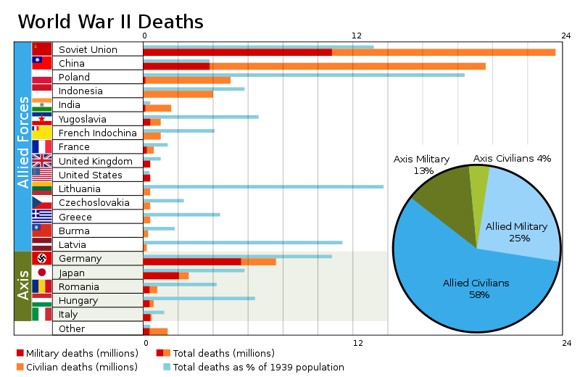  Deaths per country by number and percentage of population, with pie chart of percentage of military and civilian deaths for the Allied and the Axis Powers | 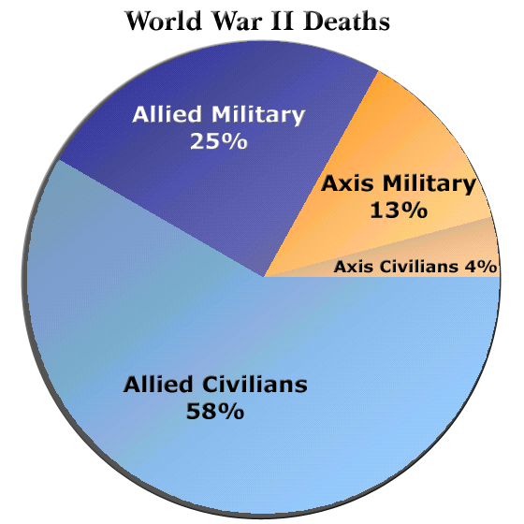  Military and civilian deaths during World War II for the Allied and the Axis Powers.

