Media and Voting patterns
TV and Radio
Broadcasters make billions in profits while using the public airwaves for free. In return, they are supposed to provide programming that fulfills community needs. Instead, lobbyists have successfully fought to make it easier for broadcast companies to gobble up even more free airspace while doing less to serve the public.
- Why would public “airspace” be important?

Cable and Telecommunications
Access to high-speed Internet service — also known as broadband — has become a basic public necessity, just like water or electricity.
- Would you consider internet service to be a necessity?
Yet despite its importance, broadband access in the United States is far from universal. Millions of Americans still stand on the wrong side of the "digital divide," unable to tap into the political, economic and social resources of the Web. Meanwhile, cable and phone companies — which hold virtual monopolies over the infrastructure of the Internet — often refuse to build out high-speed broadband to regions that need it most, and actively seek to block communities from seeking their own broadband solutions.
- Like who? Where? * Should that be legal?
Print
Consolidation has contributed to tough times for the newspaper industry. When the industry was swimming in profits in the 1990s, big media companies used 14–27 percent profit margins to buy up other properties rather than invest in the quality of their existing products or innovate for the future. Now they want to make it possible for a given company to own a newspaper and a broadcast station in the same market.

- What might be wrong with that?
Internet
Giant companies like Apple, Facebook and Google are slowly reconstituting the Internet's walled gardens of old. As these companies try to steer us to their increasingly closed versions of the Internet — and to marketers who benefit from mining our personal information — we must fight for policies that protect our rights as Internet users.
- Shouldn’t we have to give our permission for them to do that?

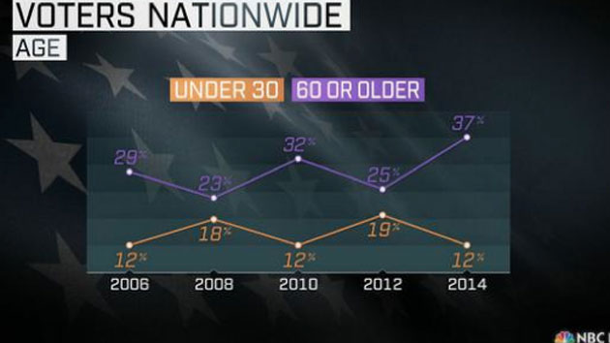

- What could be done to improve voter participation?

