The Opinion Pages | Op-Ed Contributor, New York Times

Let’s Expose the Gender Pay Gap
By JOANNE LIPMANAUG. Aug. 13, 2015

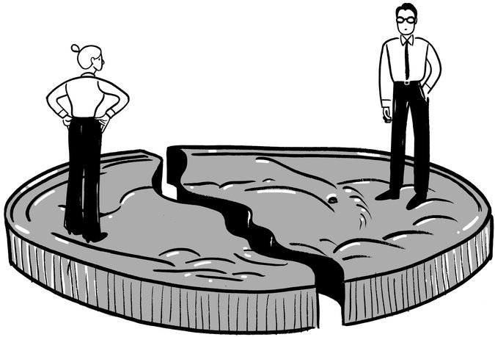

HOW serious are we, really, about tackling income equality?
The Securities and Exchange Commission took a shot at it last week, approving a rule that would require companies to disclose their C.E.O. pay gap — comparing how much chief executive officers take home compared with ordinary employees.
That’s a fine idea. But here’s a better one: require companies to publish their gender pay gap.
Think about it. Calling out top executives for making too much money will at most embarrass a few suits. But calling out companies for paying women too little will help millions — and perhaps crack one of the most intractable problems of our time.
More than a half-century after President John F. Kennedy signed the Equal Pay Act of 1963, the gap between what men and women earn has defied every effort to close it. And it can’t be explained away as a statistical glitch, a function of women preferring lower-paying industries or choosing to take time off for kids.
Claudia Goldin, a labor economist at Harvard, has crunched the numbers and found that the gap persists for identical jobs, even after controlling for hours, education, race and age. Female doctors and surgeons, for example, earn 71 percent of what their male colleagues make, while female financial specialists are paid just 66 percent as much as comparable men. Other researchers have calculated that women one year out of college earn 6.6 percent less than men after controlling for occupation and hours, and that female M.B.A. graduates earn on average $4,600 less than their male classmates for their first jobs.
It’s not that men are intentionally discriminating against women — far from it. I’ve spent the past year interviewing male executives for a book about men and women in the workplace. A vast majority of them are fair-minded guys who want women to succeed. They’re absolutely certain that they don’t have a gender problem themselves; it must be some other guys who do. Yet they’re leaders of companies that pay men more than women for the same jobs.
Women are trying mightily to close that chasm on their own. Linda Babcock, an economist at Carnegie Mellon and co-author of the book “Women Don’t Ask,” has found that one reason for the disparity is that men are four times more likely to ask for a raise than women are, and that when women do ask, we ask for 30 percent less. And so women are told we need to lean in, to demand to be paid what we’re worth. It’s excellent advice — except it isn’t enough.
There is an antidote to the problem. Britain recently introduced a plan requiring companies with 250 employees or more to publicly report their own gender pay gap. It joins a handful of other countries, including Austria and Belgium, that have introduced similar rules. (In the United States, President Obama last year signed a presidential memorandum instructing federal contractors to report wage information by gender and race to the Department of Labor.) The disclosures “will cast sunlight on the discrepancies and create the pressure we need for change, driving women’s wages up,” Prime Minister David Cameron said last month.
Critics of the British plan protest that it’s too expensive and complex. Some contend that it doesn’t address the root of the problem: systemic issues that block women from higher-paying industries, and social issues like unconscious bias.
But real-world results suggest otherwise. Last year, the consulting firm PricewaterhouseCoopers voluntarily released its gender pay gap in Britain, one of five firms in the country, including AstraZeneca, to do so. Simply saying the number out loud “created much more momentum internally” to close it, Sarah Churchman, who runs the firm’s British diversity and inclusion efforts, told me.

PricewaterhouseCoopers’s analysis showed that most of its 15.1 percent pay disparity (compared with a Britain-wide gap of more than 19 percent) reflected a lack of women in senior jobs. So the firm focused on whether it was promoting fairly. In 2013, the grade just below partner was 30 percent female, yet only 16 percent of those promoted to partner were women. A year later, the percentage of women promoted to partner had more than doubled.
The firm’s executives were also stunned to find a bonus pattern that favored men. The analysis showed that men who were passed over for partnership were routinely offered retention bonuses to keep them from quitting. Women weren’t. Ms. Churchman believes that’s because men often threatened to leave, while women typically decided to work harder and try again next year.
The potential cost savings of publishing the gender wage gap are enormous. About 20 percent of large companies now train employees to recognize unconscious bias, spending billions of dollars to try to stamp out unintentional discrimination. Paying for a salary analysis is cheaper and potentially more effective. Evidence also suggests that less secrecy about pay results in greater employee loyalty and lower turnover.
There’s a strong argument to be made for transparency not just for women, but for minorities and other disadvantaged groups. African-American men earn less than white men, for example, though a Harvard Business Review analysis found that controlling for education, black men out-earn both white and black women.
Political realities being what they are, the chances of achieving that kind of transparency are slim; even the tepid C.E.O. pay gap rule took the S.E.C. five years to push through, in the face of fierce industry opposition.
But why would we not want a measure that will settle the controversy over the pay gap with quantifiable facts? Shining some much-needed sunlight on the gender wage gap will make a difference for every one of us, men and women, right now.
Joanne Lipman is working on a book about men and women at work. She is a former editor at The Wall Street Journal and editor of Conde Nast Portfolio. A version of this op-ed appears in print on August 13, 2015, on page A21 of the New York edition with the headline: Let’s Expose the Gender Pay Gap

